SQL Server LIKE operator

* (%): tek karakter, herhangi bir karakter dizisi, boşluk yerini tutar.
* (_): tek karakter yerini tutar.
* [list of characters]: verilen karakter setindeki karakterler.
* [character-character]: verilen aralıktaki karakterler.
* [^]: değil veya alma anlamına gelir.

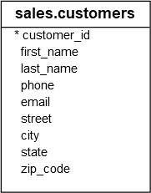

last_name **LIKE** 'z%'

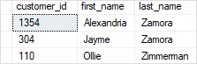

---------------------------------------------------------------------------------

last_name **LIKE** '%er'

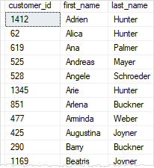

-------------------------------------------------------------

last_name **LIKE** 't%s'

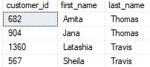

----------------------------------------------------------------------------------

last_name **LIKE** '_u%'

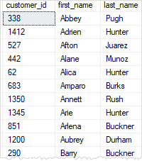

**--------------------------------------------------------------**

last_name **LIKE** '[YZ]%'

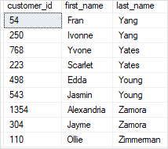

---------------------------------------------------------------------------------

last_name **LIKE** '[A-C]%'

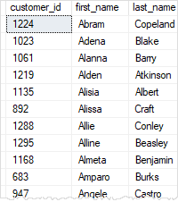

----------------------------------------------------------------------------------

last_name **LIKE** '[^A-X]%'

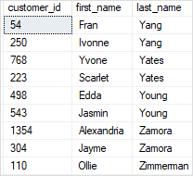

---------------------------------------------------------------------------------------------------------------

first_name **NOT** **LIKE** 'A%'



